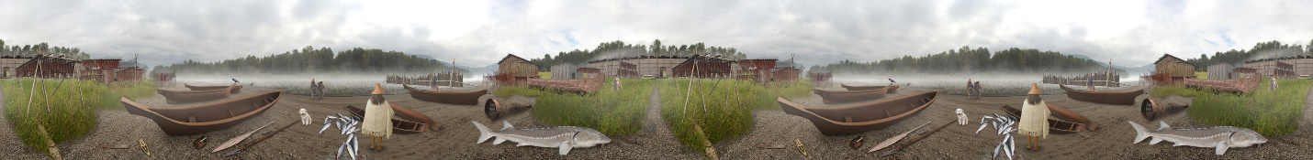

Uses of Cedar Bark
Cedar bark was used in the production of rope, mats and basketry-often combined with other elements of the cedar, such as the limbs (withes ), roots, or boughs, for strength or decoration. In the past, cedar bark was the main material used in the production of clothing for the Stó:lō people. Today, the soft material is often used in the making of regalia.
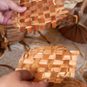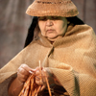

xhpey'ulhp (Red Cedar)
The red cedar is a coniferous tree that exists primarily from southern Alaska to the northernmost areas of California. These trees grow in damp conditions, which can range from the water's edge to areas as high as 1500 metres inland, typically shallow slopes near creeks and rivers or at the edge of lakes. The tallest trees are found in areas where the soil is moist, and where their roots can run deep. In these places, clusters of red cedar can be found within a towering canopy, with little foliage between the ground shrubs and the high leaves of the cedar.
The red cedar can reach heights of up to 70 metres, have a trunk diameter of 4.5 metres and be as old as 1000 years. Unfortunately, these old-growth trees are harder to come by, as logging and habitat destruction plague the trees. The leaves of the red cedar are smooth to the touch and tend to grow in opposite pairs, away from the branch. These leaves are connected to large, slim branches that are very strong and flexible.
The interior of the red cedar contains an oil that is toxic to most fungi. This oil allows the tree to resist rot, which is very common in the moist forests of the Northwest Coast. Due to this unique quality, a mature cedar that falls in the forest may remain on the forest floor for many decades without decomposing. Interestingly, due to the lack of this oil in red cedar saplings, mature trees will often have a rotten centre that was created during their early stages of life.
The red cedar is composed of many layers-each being utilized by the Stó:lō people. The hard outer bark was used for canoe bailers, while the fibrous inner bark could be used for diapers and tissues-shredded and pounded bark was also used for clothing. The inner wood of the red cedar was widely sought for use in canoe building. The limbs of the red cedar were used for rope; the roots were used in the production of baskets and the boughs for mats in the longhouse.
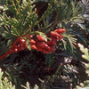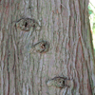

Pa:xuluqw (Yellow Cedar)
The yellow cedar can grow to a height of 45 metres and may have a trunk diameter of up to one metre. The yellow cedar is an evergreen tree that can be identified by its vertically hanging branches that appear flattened. The strong, fibrous inner bark is a yellow colour and quite soft to the touch. The wood of this tree is quite pungent and very sturdy, but does not split easily. Similarly to the red cedar, the yellow cedar thrives in very wet conditions near streams and rivers; it, however, prefers a deep soil. This tree is found from Oregon to Alaska, maintaining higher elevations in milder climates and reaching down to sea level as temperatures become colder with increased latitude. The yellow cedar does not have the same fungi-resistant oil as the red cedar, and is more prone to rot. The Stó:lō used this tree for building canoes, basketry, and for carving utensils.
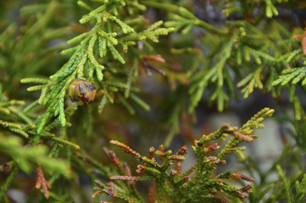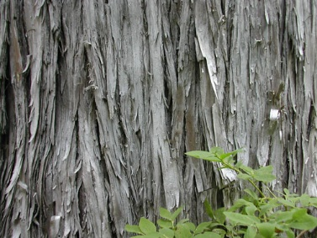
www.centralcoastbiodiversity.org www.vancouverobserver.com

Wood and Woodworking
In selecting a cedar tree to fell, the Stó:lō have to consider a number of things. Is the tree straight and free from knots? Is the tree free of rot in the interior sections? An initial assessment for rot is to hit the tree to listen for a hollowed trunk. This initial test is followed by making a small hole into the tree that extends to the centre of the tree. This test hole enables the tree-faller to assess the state of the wood on the inside of the tree.

Felling a Tree
One of the easiest ways to fell such a large tree is to burn through the trunk and adze out the softened, burnt wood. The process of burning the trunk does not require that a fire be started at the base of the tree, but, rather, heated rocks are transported over a short distance and placed in a small hole cut in the bottom of the tree and left to singe the wood. The singed wood is then removed with an adze and the process is repeated until the tree falls. Once felled, the cedars are de-limbed and dragged to the nearest body of water to float to an area where they can be processed.
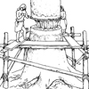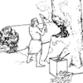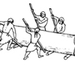

Use of Cedar Planks
Cedar planks were a primary part of building in the Fraser Valley and the greater Northwest Coast. The shed-roof houses of the Coast Salish relied heavily on the production and maintenance of cedar planks. Planks were produced, and often stockpiled, to add on to the longhouses when arrivals were expected from extended families.
Planks were produced through the use of wedges and a hammer to separate the wood planks from the larger trunk along the grain of the tree. The most controlled variation of this method involved chiseling out grooves on either side of the plank-to-be, and then driving wedges into the grooves to begin removing the plank from the log or tree. Once the plank began to separate from the log, a pole was inserted horizontally between the plank and the log. As the wedging and hammering advanced the removal of the plank further down the log, this pole was advanced to keep the plank under tension. The pole could also be used to pry the plank off the log. This technique could be repeated to produce multiple planks from the same log.
Many of the planks did not require any further processing, other than some minor finishing to the surface. On the other hand, some of the planks might have had knots or a wood grain that was not straight. Several methods were used to reduce or eliminate these problems. The most basic method involved placing the warped board onto a straight board and laying very heavy rocks onto the areas of the warped board that required straightening. Another method involved 'sandwiching' warped planks between straight planks and binding them tightly together to force any warped features out of the wood.
The creation of a smooth surface on the wood plank was important to the design of carvings or painted objects. The wood was typically primed for use by smoothing the surface with a flat sandstone rock, to which sand was added in order to increase the grit. The finish could be further refined by rubbing dogfish skin on the surface.
The durability and versatility of cedar made it an important resource to the Stó:lō people, who used it for more than just planks and carvings. The ability to steam and bend cedar with little difficulty made it an excellent raw material to produce cedar boxes, children's cradles, and drums.
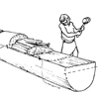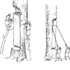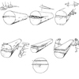

Bark
Cedar bark was a very important resource for the Stó:lō people. The bark was used for a number of items, including rope, mats, clothing, and basketry.



Bark Stripping
In addition to being a functional task, the collection of cedar bark was a spiritual time for the Stó:lō. The importance of prayer, prior to the removal of any part of the tree, was a reflection of the importance of cedar as a gift to the people it would benefit. Regardless of the activity that the bark was intended for, trees that were selected usually had similar features that made them appropriate for obtaining the correct lengths and widths of bark; generally, a tree selected for stripping was about 40 centimetres in diameter.
Other attributes the Stó:lō looked for in their selection included minimal twisting in the bark and a limited number of branches on the tree. In addition, the trees were sometimes selected for their proximity to hill slopes, as this could aid in the stripping process. The time of year for bark stripping varied along the Northwest Coast, but the Stó:lō typically harvested in late spring, as sap flow increases with the increase in temperature, and bark is more easily removed when the sap is flowing
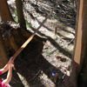

Bark Processing
To use the bark strips, first the inner and the outer bark needed to be separated. This usually involved the use of a small, sharp tool to physically separate the bark. The bark could also be separated by breaking it at intervals of suitable length to pull the outer bark away from the inner bark. Drying was the next stage in processing the bark; this was accomplished by hanging the bark or laying the bark out flat on the ground until it had fully dried.
The inner bark was the major focus of the processing efforts, and entailed turning what could be considered a hard, coarse material into something which would scarcely be considered a wood product. Shredding was the most common method to soften the inner bark, but was primarily used on young tree bark, as the bark is thin and easier to process. Shredding required absolutely dry bark; sometimes, to ensure the bark was completely dry, it was passed over a fire before working it. The bark was then laid over a hard, rounded wood surface or stone, and beaten with a hardwood implement. Depending on the thickness of the bark being processed, the amount of time and energy required to separate the fibrous layers of the bark could differ immensely.
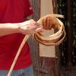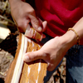

Uses of Cedar Bark
Cedar bark was used in the production of rope, mats and basketry-often combined with other elements of the cedar, such as the limbs (withes ), roots, or boughs, for strength or decoration. In the past, cedar bark was the main material used in the production of clothing for the Stó:lō people. Today, the soft material is often used in the making of regalia.

Rope
Rope was probably one of the most important materials produced from cedar bark, as it was needed for a multitude of uses such as binding the planks of the longhouses, carrying containers used for storage, and for all types of fishing-related items. The strength of cedar bark was ideal for creating rope. The making of rope involved a number of even-width bark strips that were individually twisted in a smooth motion to create the rope. The number of pieces used and the size of the bark strips were indicative of the strength of the final product.
Extending the rope beyond the length of the initial bark strips required the ends of the bark being matted with a new bark length, which had been moistened. These two pieces were then twisted together and the new piece was twisted into the rope as an extension. It was important to stagger the matted joints within the rope, as these joints were the weakest portion of the rope. This process was continued until the desired length of rope was obtained. To increase the overall strength of this rope, the ply (number of bark strands) could be increased to three or more.

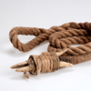

Mats
Cedar mats were invaluable to the Stó:lō people. The weave of the mat ranged from 5 to 20 millimetres, depending on the softness needed for the intended purpose of the product. Families had several mats of different weaves for their own use. Mats could be placed on the walls or roof of the longhouse to keep the cold and rain out, and were hung in doorways to prevent drafts. Some of the daily activities that required the mats were drying berries, cleaning fish, and clam digging. The mats were even used as protective pads when carrying heavy loads. People were birthed on and buried in cedar mats. Small mats covered cooking and storage containers. Once the Stó:lō people saw sailing ships, canoes were equipped with large mats hung from a mast for propulsion.
Mats also played ceremonial roles and had significance in different social situations. Screens were made from mats for utilitarian purposes of privacy, but also to provide a background for ceremonial events. Great feasts had guests eating, sitting, gambling and sleeping on mats.
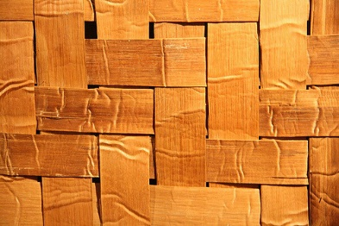
www.flickr.com (Hadzic Rock)

Clothing
Shredded cedar bark and oiled bark were used on the Northwest Coast to provide adequate protection from the cold and wet. The Coast Salish made and used three main types of clothing in the past-a tunic top, a wrap-around skirt, and a poncho.
The tunic top was designed to slip over the wearer's head (generally a female) and to drape down over the front and back of her torso. The wrap-around skirt was worn in multiple ways. Men tended to wear it from just above the waist to below the knee, while women wore such items either from the waist to the ankle, or from just above the chest to just above the knee. The rain poncho resembled the wrap-around skirt, but was generally made with a much tighter weave (to increase its water repellency).
These garments were made using shredded bark that was rolled and sewn together to form tight rows of soft bark, generally following the openwork method that is described in the weaving section.

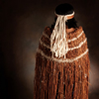

Basketry
Basketry and other weaving technologies were a significant part of the culture and lives of the Stó:lō people. Baskets made from cedar are very durable and have a long life span. Basket weaving was primarily an endeavour of female artisans, and skill training for weaving and basketry began at a young age. Cedar weaving was a vital component of the Stó:lō life-way, as basketry was used for food gathering, cooking, eating, food storage, and much more.
The weave selection in basket-making was determined by the final use of the basket. Weaving that was diagonal rather than horizontal produced a flexible item that could be folded and stored without the volume of a rigid basket. The type of weave used in a basket was also an indicator of identity, as one's extended family was most likely responsible for one's basketry skills, and each family used a specific style. Material also played a role in the type of weave being used, because of the limited availability of certain roots or bark. Additionally, many of the weaves took on a more decorative finish, especially with the inclusion of dyed materials, to highlight the weaver and his or her connection to the finished piece.
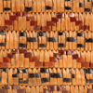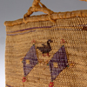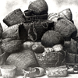

Withes
The cedar withes are the smaller sub-branches of the main branches of the cedar tree. There are also occasional withes that grow directly from the cedar trunk. Withes, once harvested, can be used as cordage without modification; they are sometimes referred to as the 'bungee cord' of the forest.
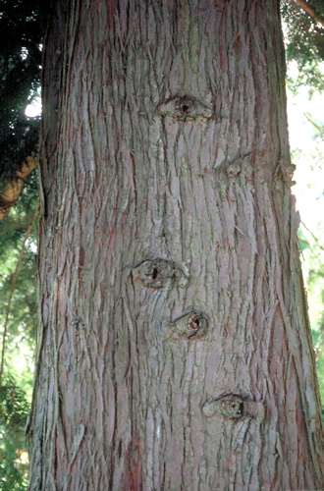

Collection: Twisting the Withes
It is important to remove the bark in withes collection, especially if they are to be stored for any great length of time. The soft wood underneath the bark is quite pliable, and can remain flexible if processed correctly. For withes to maintain permanent flexibility, they are heated over a fire, and then the lateral bonds between the fibres are broken by twisting the withes (and keeping them twisted). Another method to ensure flexibility is to twist the withes while they are still on the tree, and to cut off the resulting product with a knife

Collection: Straightening the Withes
Straightening the withes is accomplished by removing as much of the sap from the withes as possible by squeezing them along their length, from the thick end to the thin end. It should be noted that withes are best collected when the sap is running, as the bark is easier to remove and the withes are generally more flexible. When withes are collected out of season, there is a great deal more difficulty in removing the bark.
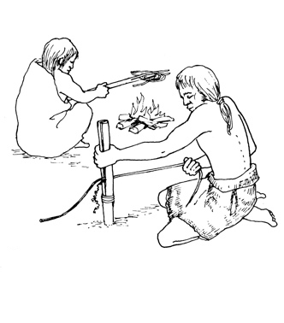

Cedar Roots
Cedar roots were an essential resource to the Stó:lō people. The cedar root basket, made using the coil method, was a basketry type used almost exclusively by the Coast Salish. These baskets could be quite large, with some collected samples being 91 centimetres by 56 centimetres. The tight weave was most utilized in creating containers that could keep liquids or moisture in or out.

Cedar Root Collection and Processing
The Fraser Valley is an especially favourable area for the collection of the cedar roots used to make baskets, because much of the valley has a high sand content in the soil, especially around the river's edge. Cedar root collection would be especially easy-going, as compared to collection in areas with less sandy soil. This practice almost entirely relied on the collection of roots from old-growth cedar, as it is reported that second-growth cedar does not produce the same type of root as old-growth cedar, and its roots were considered inferior.
Once the root was collected, it was shed of its outer layer by drawing it through a split branch which was held tightly closed; the root was then split in half down the middle and several times further down its length. The end product was dried and stored. Cedar roots needed to be soaked prior to use when stored for long periods of time.

Cedar Root Use in Design
The Coast Salish used a specific decorative technique called imbrication , which involved the integration of geometric designs into a basket. This design technique was accomplished by using several different colours (all derived from different materials). Western bitter cherry provides a bark which can be processed to a mahogany colour or black colouring, while the stems of various grasses provide a cream colour. Once these elements were woven into the basket, it would only be possible to see these pattern designs from the outside of the basket-quite an impressive feat.

Red Cedar
A long time ago there was a kind and generous man who always helped those in need. When they were hungry he fed them. When they were cold, he gave them happiness.
The Creator witnessed this and said, "This man in a good person. When he dies and where he is buried a cedar tree will grow. From this tree the people will use the wood to build their homes and canoes, from the roots they will make baskets, from the bark they will make clothing, rope and twine, from the boughs they will brush away sickness and sadness. To the people I give you this tree in honour of this man who was so kind and generous to all people. The cedar will take his place and look after you". This happened many thousands and thousands of years ago. Today our people still make use of the red cedar as the Creator intended. Like many of our trees the cedar is in danger. There are very few old growth trees left and many young trees are cut down to use as hydro and telephone poles. When you drive down the highway these poles are standing along the road, holding hydro and telephone wires. So you all still receive help from the cedar tree. It helps carry electricity to your home so that you may keep warm and cook your food. If you were not fed and kept warm you would be sad.
So the cedar tree is still doing what the Creator wanted it to do. Think about this and when you drive down the highway, give thanks to the Cedar.
As told by Chief Frank Malloway

