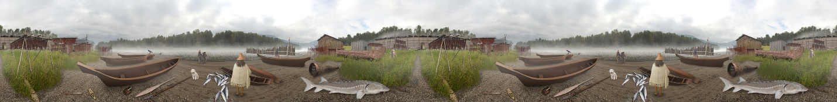

Salmon and Fishing
Fishing has always been a primary activity with the Stó:lō people. Salmon, including pink, coho, sockeye, spring, and chum, is the main food source for the people of the river and is central to their economy. As only a small portion of the salmon catch is cooked fresh, a majority of the salmon caught is preserved by wind-drying, salting or smoking to provide a resource that can be consumed throughout the year. Wind-dried salmon can last up to two years, and it was commonplace to trade this preserved salmon with people in other territories for resources not available in the Fraser Valley. Salmon is also intricately woven into the Stó:lō spiritual beliefs, and many of the oral narratives speak of this fish as having a very important role in the origins of the Stó:lō people and the Stó:lō way of life.

Types of Fish
The Stó:lō have access to many types of fish in the waterways of the Fraser Valley, including pink salmon, coho, sockeye, spring salmon and chum.

Pink salmon

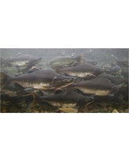
www.bhg.com

Pink salmon is an interesting salmon species. These fish change a great deal during the salmon spawn. Also known as humpbacks, male pink salmon experience a great change during spawning, growing a large hump on their back and a pronounced hook-jaw, and change colour to a yellowish-red side. At sea, pinks are a blue-green metallic colour with a silver ventral area (belly), and have black spots. These salmon are not very big when compared to the spring salmon or the coho, but can be up to a respectable 5 kilograms, and would be 75 centimetres long at this weight. Pink salmon normally spawn during the month of August. Once hatched into fingerlings, they head straight to the estuaries to get used to salt water. They then take to the sea for 18 months, after which they return to their spawning stream to start the cycle again.

Coho salmon

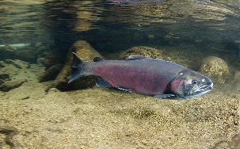
ocean.si.edu
Similar in size to a pink salmon, the coho can be up to 90 centimetres in length and normally weigh between 2.5 and 5 kilograms-but very large coho have weighed up to 12 kilograms. They have a bluish-black body and develop silver sides while in the sea. During the freshwater journey upstream to the spawning grounds, the coho develops a hook in its nose. Coho spawn during the winter months, and the resulting fry can stay in the stream network for up to a year, usually going to the estuaries in the second year of life. Coho are caught in small streams by the Stó:lō, with the help of spears.
Stó:lō stories speak of the origins of the hooked nose of the coho. The story tells of a mating pair of coho swimming upstream, against a very strong current. Needing a break from the tiring swim, the coho formed a hooked nose to catch over submerged branches to rest during the swim. When the coho arrived at the spawning grounds, the nose maintained the hooked shape and the coho decided that this was a great advantage for the upstream trip. Since this event, the coho's nose develops a hook while advancing upstream to spawn.

Sockeye salmon

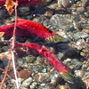
Sockeye are one of the favoured fish for consumption in the Stó:lō territory. The wind-drying conditions in August are perfect for drying fish, requiring no smoking. During normal spring salmon spawning, the sockeye runs were used to collect fish oil, which was used much in the same manner that margarine is used today. These fish were usually caught earliest in the spawning season, as the oil content of the fish is highest early in the run.
Typical sockeye are greenish-blue with black speckles, changing to light-green heads, bright-red body, and dark jaws when spawning. They can reach a maximum of 84 centimetres and 7 kilograms. Sockeye are a unique example of the anadromous fish, as they can spend up to two years in fresh water before heading out to sea. Sockeye spawn in rivers headed by lakes, and once the fingerlings hatch, they move into these large freshwater bodies for up to a year to mature and prepare for the journey to the sea.

Spring (Chinook) salmon

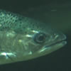
Spring salmon are a very important fish in the Stó:lō culture, being the focus of most of the fishing and drying methods that provided the largest and most valuable salmon storage reserves for the coming year. They are also the focus of the first-salmon ceremony. Spring salmon can reach an enormous 59 kilograms and a length of 147 centimetres. They have a blue-green dorsal area and head, with silver sides and a white ventral area. Their life cycle consists of one to 18 months in fresh water as a fry, a maximum of 190 days in the brackish water of the estuaries, and finally one to eight years at sea before returning to spawn.
Dip netting in the Fraser Canyon has developed into a series of special techniques which are used to catch salmon. Spring salmon is one of two salmon types which have methods designated specifically for the fish type.

Chum salmon

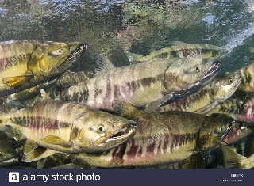
www.alamy.com
Chum salmon are the second most abundant salmon available in the Pacific Northwest, and make up a significant portion of the fish that is available for fishing purposes. These salmon are typically 75 centimetres in length and weigh 4 to 6 kilograms on average, but can be as large as 12 kilograms during spawning. Chum salmon spawn late, starting the spawn season in September, and usually completing it by early December in some places. Chum are late spawners in the Fraser River and, due to this fact, they can be used as a supplementary food source in the event of diminished spring or summer salmon runs, and be used as a part of a full-year fishing strategy. Chum were mostly eaten fresh, but could also be preserved through the use of a smoking or salting method.

Fishing Techniques
The fishing techniques used by the Stó:lō vary greatly, depending on the fish habitat and fish type. Dip netting for salmon in the narrows of the Fraser is one of the primary fishing techniques utilized to catch salmon during the salmon spawn. Netting techniques used in the Fraser Canyon are tightly linked with wind-drying preservation-a method used to preserve the large amounts of fish caught during the summer. The narrows of the river in the Fraser Canyon are so productive for this type of fishing that fishing spots are claimed as territory by family groups. Also, these fishing spots are designated to different family members during different times of the salmon spawn, giving those of the highest rank in the family, such as elders, the most productive times. Gill nets have also been used in the Fraser Canyon and the Lower Fraser to catch both sockeye and spring salmon. In the Lower Fraser, harpooning is used in the shallow waters of the Fraser River to catch a variety of salmon, and is also used for catching sturgeon in deep water all year round. Weirs can be constructed to catch fish in smaller rivers, and a variety of hooks and hook-and-line techniques are used in various waterways.
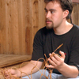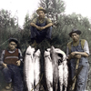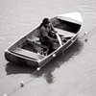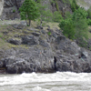

Dip-netting
Dip netting is one of the main fishing techniques used to catch enormous quantities of salmon (spring and sockeye) in the Fraser Canyon. This method involves standing above the dangerous currents of the river narrows, usually from a rock perch or a wooden platform, and dipping a large net attached to the end of a pole into the water. The net mouth is then closed, and the fish inside the net are trapped. The net is hauled out and emptied, so the process can be repeated.
Twined inner cedar bark, or spun nettle, was the primary material used in the creation of the net itself. The production of the dip nets was an extremely time-consuming process. The structure of the net included a net mouth that was attached to a vine maple hoop-this hoop was suspended at the end of a larger pole made from fir or cedar. Fixing the net to the hoop was a complicated procedure, as it had to be fixed in a manner that would allow the net to be securely attached but also be movable, in order to enable the mouth of the net to be closed when it was lifted from the water. To do this, a bone loop was placed around the vine maple hoop and attached to the net mouth to create a durable sliding mechanism that could be used to pull the net mouth closed when it was full of fish.
The two main methods to handle a dip net are based on the two different spawning patterns of the spring and sockeye salmon in the Fraser Canyon. A shallow-dipping method is used to catch sockeye. This involves sweeping the net downstream through the swirling eddy waters and catching the sockeye, which are near the surface. To catch spring salmon, the net is lowered deep into an eddy, and then closed and raised from the eddy. This method does involve using a net-hoop-pole combination which is longer than normal (at 2 metres) and has a wider hoop than normal (at 1.5 metres). A smaller hoop and pole are used in the sockeye method.
During the dip netting, the person operating the net is tied to the shore or platform. The net is tied to shore as well, as it is quite valuable. This preventative measure is very important, as the heavy fish and strong currents can make using a dip net very difficult and dangerous. The strong currents can make the river a dangerous place, especially around eddies, which is where dip netting spots are usually located.

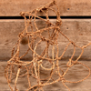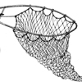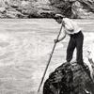
Gill-netting
Contemporarily, gill nets have almost replaced dip nets in the Fraser Canyon, and have largely extended into the middle and lower Fraser, where fish congregate in the slower eddies. Generally, the gill nets are attached to the end of a long pole, which is suspended above the river. The pole is braced with lines to maintain its position. The use of the pole in the gill netting is believed to be a recent invention-in the past, the nets were extended out into the river using a canoe, and supported in the centre with floats. The bottom portion of the net was weighted down using stone sinkers, which were ground from pebbles.
The basic premise for a gill net is that the net is created with holes that will allow fish to begin to swim through the holes, but not pass through easily, catching the fish around the gills. Once this has occurred, the net is pulled from the river with the fish. Gill nets are not as successful as dip nets, as there is less chance of actually catching fish, but are much easier to handle than the dip nets.
Drift nets are a form of gill net. They are typically used in the slower, wider areas of the Fraser, where they are allowed to float in the river without encountering too many obstacles.

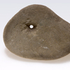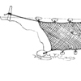

Bag Nets
Bag netting was another method to catch fish in the slower and deeper parts of the Fraser River. The bag net had a mouth, which was 4 metres by 1.5 metres, with the bag portion of the net being several metres long. The net was held within a few centimetres of the bottom of the river, using appropriately long poles. The Stó:lō were able to gauge when the net was along the bottom of the river through fixed feathers at the bottom of the net poles-the feathers were used to feel the bottom, much in the same way that feathers are used to feel sturgeon at the bottom of the river. The entire apparatus was held by two individuals on separate canoes, and these canoes were paddled very quickly downstream to catch as many fish swimming upstream as possible. A cord was released, while holding taut the trailing bag portion of the net, and the mouth of the bag net was folded closed, using the poles that held the net at the river bottom. Once the net was secured, the canoes were run ashore, and the net was emptied there. During this activity, young men often speared the fish that escaped the net.

Harpooning
Harpooning is a distinctive fishing technique used in specific fishing conditions such as shallow water fishing, and for the fishing of sturgeon.

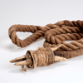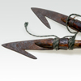

Shallow Water Harpooning
There were two distinctive activities which involved the use of a harpoon by the Stó:lō. These activities were sturgeon fishing and shallow water harpoon-fishing. The use of a harpoon while fishing in shallow water involved waiting patiently in clear, shallow eddies for a fish to chance by. Despite the simple description, catching fish with a harpoon is not a simple matter. Care must be taken not to hit the tip of the harpoon, either bone or stone, on the rocky river bottom (as this can break the tip of the harpoon). Also, as any angler will attest, refraction in the water is a consideration, as this can scare the fish and lessen the likelihood of catching any fish. The optical illusion of refraction involves the slight bending of light, or images in this case, going through the surface of the water, which can make objects that are underwater seem closer than they appear. It also enables a fish in the water to see objects out of the water, although there is not a direct line of sight.

Sturgeon Harpooning
Sturgeon fishing is a very skilled and laborious process. The harpoon point used by sturgeon fishers is known as a composite point, as it is quite complicated to create and more difficult to maintain. It is made of several pieces that are bound together and attached to a rope, which is used to pull in the sturgeon once harpooned. The harpoon point is made of a bone or stone tip, with bone barbs on two sides of the point. Generally, harpoon points are loosely attached in pairs to the two branches of a special shaft that is shaped like a "Y". In addition, stiff feathers are fixed to the shaft, extending slightly further than the harpoon point. The "Y" sections are attached to straight sections that are lowered into the water, extending the length of the harpoon up to 13 metres.
Sturgeon fishing took place in the deeper parts of the Fraser River, where it is known that the sturgeon lie on the bottom of the river, facing upstream. Patient fishers stood in their boats, with a paddler advancing the boat, gently feeling along the bottom of the river with the feathers (fixed to the shaft), searching for the large bump in the river bottom that was a sturgeon. It was important that this tactile search be done with feathers, as using the tip of the harpoon would poke the sturgeon, causing them to swim away. Once a fisher had felt the sturgeon on the bottom of the river, he drove the two harpoon points into the sturgeon and pulled the shaft and Y-shaped section off the harpoon tips, relying on the cordage that was fixed to the tips to "reel" the sturgeon back to the boat.
As the sturgeon was such a large fish, it was likely that it would start swimming away from the boat, dragging the fishers with it. Sometimes the fishers would drop large stone anchors off the boat to slow the fish down. Once the sturgeon was tired, they could pull the fish to the boat and club it on the side of the head.
Transporting the caught sturgeon was difficult. Fishers had several methods of transport, which included manually hauling the fish into the boat, capsizing the boat and turning it back over with the fish in it (then bailing the boat), or paddling with the fish being towed behind. These activities were very difficult, due to the size and weight of the fish.
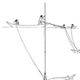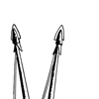

[Video of Sturgeon Swimming]

Weirs and Fish Traps
Weirs and fish traps are a well-known fishing method for much of the Northwest coast of North America. The Stó:lō used fish weirs on streams, rivers and shallow estuaries. Some large rivers were also fished using weirs, such as the Chilliwack River. Large fish weirs were communally maintained and used by an entire village. Smaller fish traps were also used, but these were usually owned by an individual or family, and stored indoors when not in use.
River-based fish weirs tend to involve the creation of an impassable object that forces the fish, mostly salmon in the case of the Stó:lō, towards a hole, or breach, in the weir, which usually has some form of fish trap or fisher person waiting to catch the fish. Tidal fish weirs tend to rely on the ability of the ebb (low) tide to create pools and small streams flowing back out to the ocean. Weirs are placed to block the fish, which came up the beaches with the high (flood) tide, from returning to the sea with the lowering of the tide. Traps and fishers with spears caught what was left in the weir when the tide receded.
Traditionally, fish weirs were constructed using a lattice network of wood, which was temporarily placed between a permanent structure of thick branches of wood. The thick branches were the main structure of the weir, but also maintained the position of the weir in a favourable location. The structure also provided the fisher with a marker, which allowed him not to have to remember the specifics of the behaviour of the river or stream when the water was high, or, more importantly, the tidal behaviour of a beach.
Fish weirs also provided an interesting scenario for neighbourly relations. Due to the ability of a weir to completely block a river, those that were further down the river could block all fish moving upstream, thus preventing them from getting to weirs and fishers further upstream. To counter this behaviour, an upstream neighbour could send a large log down the stream to damage or destroy any traps or the weir itself, getting revenge for such greedy behaviour. River weirs also exposed their owners to land management issues, to which casual anglers may not have been exposed. Due to the strong inclination of salmon to return to their place of birth, care had to be given not to block the return of too many fish, as this might disrupt the spawning patterns. Building a fish weir in a spawning habitat could reduce the number of fish that returned to the rivers and streams each year.

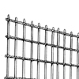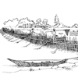

Eulachon Fishing
Although limited geographically from the mouth of the Fraser to its confluence with the Harrison River, eulachon "raking" was an integral part to the fishing of eulachon . Using an implement similar to the leaf rake (but with sharper tines), the fisher passed the rake through the water, subsequently impaling the fish. The rake was pulled from the water and the fish dumped into the boat. These fish were not turned into grease, as was done by other First Nations of the Coast, but were consumed fresh or smoked for preservation.

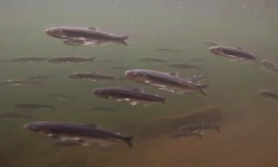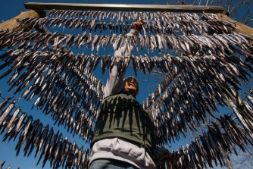
http://www.toqueandcanoe.com

Seasonality
Seasonality was an important factor in the activities of the Stó:lō people. Seasonal rounds for fishing and plant food gathering were determined by the season in which these sources were available. In the spring, temqw'iles , the first spring salmon was caught, and this was followed by the First Salmon ceremony. The summer, temkw'ó:kw'es , saw the arrival of other types of salmon and was also a time for berry picking, from the lower elevations up into the alpine areas (as the season progressed). The arrival of autumn, temhilálxw , saw the harvest of root vegetables and was also the time when hunting for animals such as deer, elk and bear took place. The winter, temxéytl' , was a time for ceremonies and the foods that were gathered, processed and preserved in the other seasons were used at this time

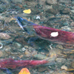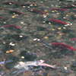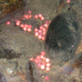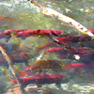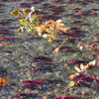

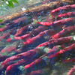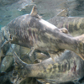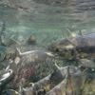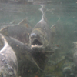

Fish Processing
Processing fish that is caught in large volumes is as important as catching the fish itself. It is only through the drying, smoking or salting process that fish will remain consumable for more than a few weeks after it is caught. It is this processing that allows the great salmon runs to be fished so heavily. The resulting product of these processes was a stable resource that could be stored for later consumption or used as a trade good-one that kept its value over long distances, unlike more perishable products. One example of the importance of this resource is the trade of wind-dried spring salmon with the Squamish, or other groups in the Interior, in return for various goods such as raw materials for tool production or furs.
The task of processing fish was also a time to reinforce family ties and social obligations, as these activities required many people-hours to complete, and a great deal of effort was required to move processed goods, once drying was completed. Salmon provided an excellent venue for the strengthening of family relations.

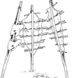

Butchering
Butchering fish can be quite complicated as different fish require slightly different butchering techniques, and different cooking and storage preparation methods will demand different cuts of fish. These processes require the utmost skill and efficiency to complete the volume of processing that is required during the salmon spawn.
Butchering salmon for wind drying is an excellent example of how special processing techniques require very specific cuts of fish. To begin, the head of the fish and the fins are usually cut off, using a coarse fishing knife. The blood is allowed to drain from the fish, taking up to 15 minutes. Cutting along the left side of the backbone, the fish is opened up to be cleaned of any remaining blood and liquids. With the fish open, hinged in the belly (ventral) skin, the flesh is cut cross-length about one centimetre apart without cutting the skin, using an extremely sharp fish knife. Wood skewers (generally made of vine maple) are then pushed length-wise through the fresh cuts from end to end, to maintain the shape of the fillets during the drying process.

Fish Knife
The traditional fish knife, kwetsetel , was made from a thin piece of slate which was hafted to a handle that ran the length of the blade. This blade, when well maintained, could be much sharper than that of many knives available today. The current availability of lower-maintenance steel knives has limited the use of the traditional slate knife.
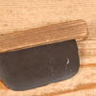

Drying
Salmon drying is one of the most important processing-for-storage techniques that are used by the Stó:lō on the Fraser River. This process occurs in two forms: wind-drying and air-drying. Air-drying took place in the normally dry areas of the Fraser Valley. A drying rack, a rectangular structure of poles, was covered with a roof, and salmon flanks were hung within the structure. The salmon was cut thin for this type of drying to reduce the chance of poor weather spoiling the batch. The roof was integral to the success of the drying, as it prevented exposure to the sun and to any showers, which would both have spoiled the fish.
Wind-drying uses the hot summer winds that are funneled into the Fraser Canyon to remove moisture from hanging salmon, most likely caught in the same area of the Fraser River. Drying racks, similar to the air-drying racks used in the Fraser Valley, were erected on the highest perches near the river and convenient processing areas. Perching the fish in these areas exposed it to the strongest winds of the canyon, which hastened the drying process and limited the amount of insects having access to the salmon. It took a week for the salmon to dry to a consistency similar to that of beef jerky. The drying racks used to wind-dry are still utilized, and can be seen from the Fraser River and from the highway that travels alongside the canyon.

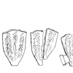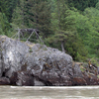

Smoking
First Nations are famed for their incredible smoked salmon and have exported the flavourful products of this tradition throughout the world. The Stó:lō have an exemplary tradition of smoked salmon, especially in areas that are less appropriate for drying. The fish is smoked in a smoke house-a structure which is enclosed on all sides and has small openings at the top to allow the smoke to slowly escape.
Smoking salmon usually involves a small amount of salt curing and a long stay in the smoke house prior to storage. First, the salmon is cut dorsally (along the back) about one centimetre from the spine on both sides. The spine and tail are removed, as well as the innards. Next, the fish is washed thoroughly and allowed to drain. The salmon is then salted and stacked, leaving the fish to sit for at least five hours to cure, or overnight for a saltier fish. After the salting, each fish is skewed horizontally and then hung from the poles of the smoke house. The length of time a fish is smoked depends a great deal on what the intended use of the fish will be. In the past, the salmon were kept over the fire to smoke for more than a week. This long smoking period allowed the fish to be stored without risk of spoilage. Today, the Stó:lō people will often smoke the fish for only 24 hours and then store it in a freezer.
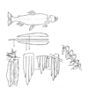

Salting
Salting fish is also a common practice for the storage of all types of salmon. Salt was collected from the surrounding mountain peaks in the Fraser Valley. The butchering practice is similar to that used for wind-drying, involving dorsal cuts, and the removal of the spine and innards. The fish is then opened on its belly and placed skin down in a storage container (barrel or crock pot) and salted. This process is repeated until the container is full. After the last salmon has been salted, it is placed skin side up, and a heavy object is placed over the fish to keep them in the container. The latter is then sealed and ready for storage.
Consuming salted salmon requires the removal of the salt. Salt can be very dangerous if consumed in very large amounts, and this food preservation process can be quite risky if the proper methods are not used to remove the salt that was used for curing the fish. First, the salmon is removed from the storage container, and all of the salt is washed from the fish with fresh water. The fish is then left to soak in a fresh container of water to continue to remove more salt. Once the fish has soaked for a sufficient time (about one day), it is then boiled, to both cook it and remove the last of the salt, and reduce the salty taste.

Caching
Caching was a necessary storage method in the past, because of the large amounts of fish that were being stored. Typically, caches were placed in trees or on stilted structures to prevent access from terrestrial animals and to keep the majority of insects away (although it should be mentioned that insects are not really a threat to dried, smoked or salted salmon, as most insects are looking for decaying or rotting meats). In addition, these high locations kept the damp and ground-based moulds off the cached goods. Notched ladders were located near or at the caches and the resources that were cached were stored in some form of basket or box.

The Salmon Story
When the Creator was still creating Mother Earth, there were a lot of things we have today that were not here at the beginning. For food we had a lot of meat. There were deer, elk, bear but when you eat meat you always have a heavy feeling in your stomach. You feel weighted down. Our people prayed to the Creator for something different, something lighter. The Creator spoke to a Siam and gave him instructions. "You make a dip net and go to the river. There you will see something swimming in the river, these are salmon. Dip one out and roast it by the fire. Share this food with your people. Then gather up all the salmon bones, place them on cedar bark and return them to the river. The river will take the bones back to the salmon people who live in the Sea. If you don't show your respect in this way, not many salmon will return to the river. You have to give thanks to the Salmon People for sending their children up the river to feed us."
This is how the Creator gave us the salmon.
Told by Ed Leon, Chehalis. Retold by Frank Malloway.



