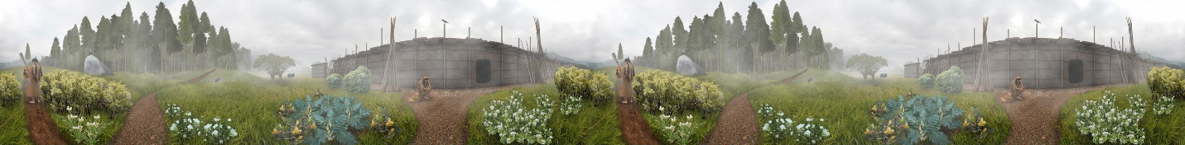

Weaving
Weaving has always been important to the Stó:lō people and is a tradition that is still avidly practiced today. Those individuals who are gifted at the skill of weaving are commissioned to produce beautiful blankets now made of mountain goat wool, and in the past of woolly dog hair, for the chiefs and elders throughout the Fraser Valley. The woven blankets, used as clothing, are worn on ceremonial occasions, and are also symbolic of a person's wealth and status. The blankets can also be given away as gifts at potlatch ceremonies, naming ceremonies and other important gatherings.
Before the Europeans brought sheep to North America, the Stó:lō used wool from mountain goats to weave their blankets. Additionally, in the past, the wool of small domesticated furry dogs (called woolly dogs ) was also used in weaving blankets.
Blankets tell a story, much like the totems of other Salish people, and hold special spiritual power for the people who wear them. For the Stó:lō people, the blankets are significant within their culture and are symbolic of the transformation of animal products into beautiful objects signifying strength and wealth.
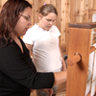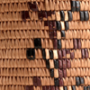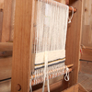

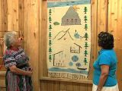 Minnie’s Story Blanket

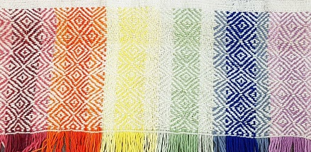 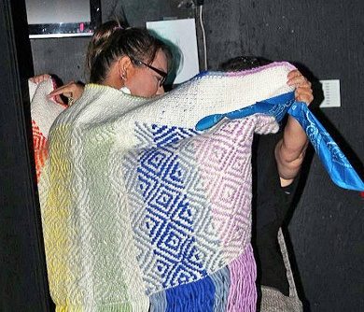 LGBTQ2S Blanket, MSS
Mission City Record story about LGBTQ2S blanket woven at Mission Senior Secondary School
https://www.missioncityrecord.com/community/woven-blanket-presented-to-salish-wesley/

Technology
The Stó:lō use spindles and spindle whorls to spin their wool and a standing loom to weave. The Stó:lō, as part of the Coast Salish peoples, were one of only two indigenous groups in North America to use this type of weaving method-the Navajo were the other. Spindle whorls are usually elaborately decorated and are very personal items associated with the weavers themselves. At the most basic level, weaving with a loom involves a vertical row of string pulled taut (the warp) and a material which is pulled through these strings (the weft), alternating between going in front of the warp and behind the warp.
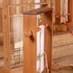 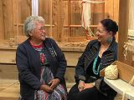 Minnie Peters -- Sto:lo Weaver

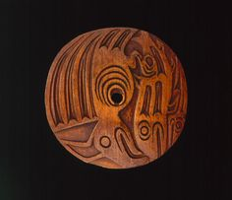
Coast Salish Spindle Whorl : https://www.pinterest.ca/qwalsius/coast-salish-culture/

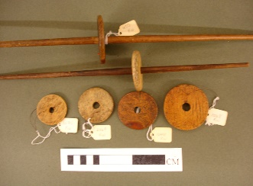
Article: Spindle Whorls in British Columbia, Royal Museum of British Columbia, 2016.
http://staff.royalbcmuseum.bc.ca/2016/12/06/spindle-whorls-in-british-columbia/

